**Microcontroller-on-Module**

**STM32 Edition v1 (MoM-S1)**

Board Architecture Specification

Author: Matt Staniszewski

Contents

Revision History 3

Overview 4

Functional Description 5

Reconfigurable IO 5

Detailed Implementation 6

Mechanical 6

Form Factor 6

Height and Clearance 6

Mounting Holes 7

Enclosure 7

Environmental 7

Temperature 7

Shock and Vibration 7

Compliance 7

Reliability 7

Electromagnetic Interference (EMI) 7

Power 7

Voltage Tree 7

Rating 8

Sequencing 8

Processor 8

Configuration 8

Clocking 9

Interfaces 9

USB 9

User IO 9

LEDs 9

Connectors 9

Interface Connector 10

Debug 10

USB OTG 10

UART 10

Test Points 11

Bring-up and Testing Procedures 12

Future Revisions 13

Appendix A: Glossary of Terms 14

Appendix B: Calculations 15

# Revision History

|  |  |  |  |
| --- | --- | --- | --- |
| Version | Date | Author | Description |
| v0.0 | 07/27/18 | MS | Initial Version |

# Overview

# Functional Description

## Reconfigurable IO

# Detailed Implementation

## Mechanical

The following section describes the mechanical requirements of the MoM-S1 design. An overview of the mechanical features of the MoM-S1 is shown in the figure below:

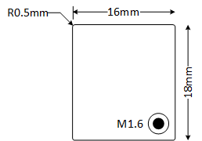

### Form Factor

The MoM-S1 measures **16mm x 18mm**, or almost a third of the size of an Arduino Nano. A scaled comparison of the two modules is shown in the figure below:

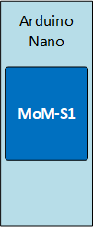

The MoM-S1 module also includes 0.5mm radiused corners.

### Height and Clearance

The maximum component heights are as shown in the following table:

|  |  |
| --- | --- |
| **Maximum Component Height** | |
| Top Side | 1.6mm |
| Bottom Side | 1.5mm – 4mm |

#### Mating Connector Height

The bottom side height requirement is driven by the chosen connector to mate with the interface connector on the MoM-S1 (**DF40C-60DP-0.4V(51)**). The mating connector has a mating height of **1.5mm**, but other variants can be chosen such that the mating height is up to **4mm**.

### Mounting Holes

The MoM-S1 module includes a single **M1.6** mounting hole in the bottom-right corner. This allows a user to secure the module to the mating board and provides mechanical stability when combined with the support from the mating connector.

### Enclosure

The MoM-S1 module was designed to be used in a variety of applications and thus the enclosure will vary by user application.

## Environmental

### Temperature

The MoM-S1 was designed to operate over a temperature range of **0-70°C**.

### Shock and Vibration

### Compliance

The MoM-S1 has not been designed to meet any specific UL, CE, FCC or other standards. Testing should be performed on the user’s specific application to confirm that the required standards are met.

### Reliability

### Electromagnetic Interference (EMI)

## Power

The following sections describe the power architecture of the MoM-S1 module.

### Voltage Tree

The figure below shows the voltage tree of the MoM-S1 module:

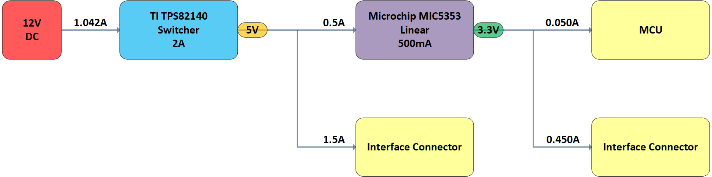

The current values shown are based on the information provided for the microcontroller, which drove the values available at the interface connector. These are based on the maximum capacity of the power circuitry itself.

A summary of the components chosen can be found in the table below:

|  |  |  |
| --- | --- | --- |
| **Voltage Regulators** | | |
| **Voltage Rail** | **Component** | **Designed Capacity** |
| 5V | TI TPS82140 | 2A @ 5V |
| 3.3V | Microchip MIC5353 | 500mA @ 3.3V |

### Rating

The MoM-S1 module has been designed such that its rated input power requirement is **1.042A @ 12V** and provides the rated output power stated in the section above.

### Sequencing

There are no sequencing requirements for power-on or power-off of the MoM-S1 module.

## Processor

The MoM-S1 module is an STM32-based device (represented by the ‘S’ in the part number). MoM-S1 will use the **STM32F070CBT6** microcontroller (MCU). An overview of the MCU specifications are shown in the table below:

|  |  |
| --- | --- |
| **MCU Specification** | |
| **Flash** | 128KB |
| **SRAM** | 16KB |
| **16-bit Timers** | 8 |
| **Communication Interfaces** | 2x SPI, 2x I2C, 4x UART, 1x USB |
| **ADC Channels** | 12 (10 external, 2 internal) |
| **GPIOs** | 37 |
| **Max CPU Frequency** | 48MHz |
| **Operating Voltage** | 2.4 - 3.6V |
| **Operating Temperature** | -40-85°C (ambient), -40-105°C (junction) |
| **Package** | LQFP48 |

## Configuration

The MoM-S module is programmed via the SWD interface on the MoM daughter board or through a custom board created by the user. The MCU is programmed using the **ST-LINK/V2** programmer. The daughter board utilizes the **ARM20-CTX** adapter and **TC2030-IDC-NL** cable from Tag-Connect for minimum footprint size. An image of the ST-LINK/V2 with the Tag-Connect adapter and cable are shown below:

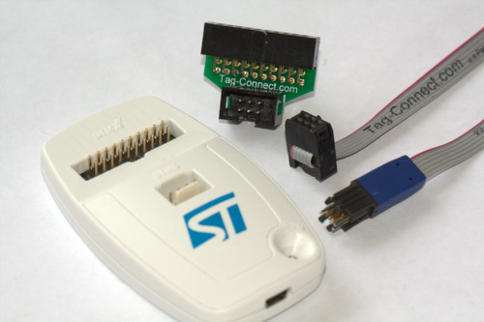

Test points for the SWD pins (SWCLK/SWDIO) and reset (NRST) are provided if the user wishes to program the MoM-S1 module without additional boards.

## Clocking

The MoM-S1 module uses a 16MHz ceramic resonator with internal capacitors (**CSTCE16M0V53-R0**) to drive the MCU and its peripheral clocks.

## Interfaces

The following section describes the interfaces available on the MoM-S1 module.

### USB

The MCU on the MoM-S1 provides a single USB 2.0 full-speed device peripheral interface that is pinned out through the interface connector (See Interface Connector section below). The data lines (**D+/D-**) are impedance controlled to 90Ω differential as per USB 2.0 requirements.

There is no USB connector or additional hardware for other USB power management, ESD protection or other features (i.e. ID, VBUS) on the MoM-S module. That hardware is located on the MoM daughter board and needs to be implemented on the user’s custom PCB if USB is to be used. Controlled impedance requirements should also be followed when implementing USB on a custom design.

### User IO

The MoM-S1 module provides **27 IOs** from the MCU to the interface connector. These may be used from any purpose. Some examples include serial interfaces (SPI, I2C, etc…), analog pins or generic IO.

### LEDs

Two user-defined LEDs are provided on the MoM-S1 module. There is one blue LED (**USER_LED0**) and one green LED (**USER_LED1**) that can be controlled. Both are active-high (sending a high signal or ‘1’ from the MCU turns the LED on).

## Connectors

TBD

### Interface Connector

The interface connector provides the main connection between the MoM-S1 module and the custom PCB that it connects to. A table with the pinout of the connector (provided as two sections) along with a key is provided below:

|  |  |  |  |  |  |  |  |  |  |  |  |  |  |  |
| --- | --- | --- | --- | --- | --- | --- | --- | --- | --- | --- | --- | --- | --- | --- |
| **2** | **4** | **6** | **8** | **10** | **12** | **14** | **16** | **18** | **20** | **22** | **24** | **26** | **28** | **30** |
| **12V** | **12V** | **GND** | **GND** | **5V** | **5V** | **GND** | **GND** | **GND** | **3V3** | **GND** | **NRST** | **GND** | **GND** | **D-** |
| **1** | **3** | **5** | **7** | **9** | **11** | **13** | **15** | **17** | **19** | **21** | **23** | **25** | **27** | **29** |
| **12V** | **12V** | **GND** | **GND** | **5V** | **5V** | **5V** | **GND** | **GND** | **3V3** | **GND** | **CLK** | **DIO** | **GND** | **D+** |

|  |  |  |  |  |  |  |  |  |  |  |  |  |  |  |
| --- | --- | --- | --- | --- | --- | --- | --- | --- | --- | --- | --- | --- | --- | --- |
| **32** | **34** | **36** | **38** | **40** | **42** | **44** | **46** | **48** | **50** | **52** | **54** | **56** | **58** | **60** |
| **GND** | **IO** | **IO** | **IO** | **IO** | **IO** | **IO** | **IO** | **IO** | **IO** | **IO** | **IO** | **IO** | **IO** | **HW_VER** |
| **31** | **33** | **35** | **37** | **39** | **41** | **43** | **45** | **47** | **49** | **51** | **53** | **55** | **57** | **59** |
| **GND** | **IO** | **IO** | **IO** | **IO** | **IO** | **IO** | **IO** | **IO** | **IO** | **IO** | **IO** | **IO** | **IO** | **IO** |

|  |  |
| --- | --- |
| **GND** |  |
| **12V** |  |
| **5V** |  |
| **3V3** |  |
| **SWD** |  |
| **USB** |  |
| **MCU** |  |
| **HW_VER** |  |

## Debug

Debug options onboard the MoM-S1 module are limited to the test points provided (See *Test Points* section below), which includes the SWD programming interface. Additional debug methods, such as UART or USB, must be configured in the MCU and pinned out either on the MoM daughterboard or user’s custom PCB.

# Test Points

Power input, USB, SWD / reset, Rails

HW_VER?

...

# Bring-up and Testing Procedures

TBD

# Future Revisions

TBD

# Appendix A: Glossary of Terms

# Appendix B: Calculations